**Freelancers Software Solutions**

**Software Requirement Specifications for   
Enhancing Motion from Video**

Written by:  
Ravishka Rathnasuriya  
Sean Aleman  
Gayal Hewakuruppu

On: March 31st, 2020

Contents

Revision History 3

1.Introduction 4

1.1 Purpose 4

1.2 Scope 4

1.3 Definitions, acronyms, and abbreviations 4

1.4 References 4

1.5 Overview 5

2.Overall description 5

2.1 Product perspective 5

2.1.1 System interfaces 5

2.1.2 User interfaces 5

2.1.3 Hardware interfaces 6

2.1.4 Software interfaces 6

2.1.5 Communications interfaces 6

2.1.6 Memory 6

2.1.7 Operations 6

2.2 Product functions 6

2.3 User characteristics 7

2.4 Constraints 7

2.5 Assumptions and dependencies 7

2.6 Apportioning of requirements 7

3.Specific requirements 7

3.1 External Interfaces 7

3.2 Functional Requirements 8

3.3 Non-Functional Requirements 8

3.4 Performance Requirements 8

3.5 Logical Database Requirements 8

3.6 Software System Attributes 8

3.6.1 Reliability 8

3.6.2 Availability 8

3.6.3 Security 9

3.6.4 Portability 9

3.7 Domain Design Model 9

3.8 Architectural Model 10

3.9 Additional Comments 11

# Revision History

|  |  |  |  |
| --- | --- | --- | --- |
| **Name** | **Date (2020)** | **Reason for Changes** | **Version** |
| Ravishka Rathnasuriya | 03/16 | Initial Review and make changes in content | 1.0 |
| Sean Aleman | 03/23 | Adding details to sections 2 and 3 | 2.0 |
| Ravishka Rathnasuriya | 03/25 | Changes to sections 3.7 and 3.8 | 3.0 |
| Ravishka Rathnasuriya | 03/31 | Final feedback and make changes to the content, add missing information and organized the structure of the document | 4.0 |

# 1.Introduction

1.1 Purpose  
  
The Enhancing Motion from Video system will be designed to serve researchers and educators in the field of computer science, physics, chemistry, engineering etc. to experiment with the ability to detect and enhance motion that is not visible to the naked eye. The researches will have the ability to add their own algorithms for testing purposes. Normal users who are not educators or researchers will be able to use the service as well, just with limited functionality and limited selectable options.

1.2 Scope  
  
The company will be using Digital Ocean to design the web server that would install and run MATLAB. It will use a Linux Server running Ubuntu 18.04  
A database will be created using SQL and phpMyAdmin and connect to the server to store the videos uploaded by the user.

Digital Ocean is helpful to create the server that will have MATLAB installed.

The user will visit a web page which allows the user to upload a video, and select options for the color amplification, as well as motion enhancement. The user also will have to select Frequency cutoffs in Hertz.

Once a user uploads a video and selects what options they desire, the system has the capability of amplifying color and motion and is able to implement new and improved phase-based motion magnification pipeline on the back end. It will then create and store a video in a database with the enhanced motion and amplification of color. The user will then be able to see the resulting video and download it if the user desires. All videos will be published to a public database.

## 1.3 Definitions, acronyms, and abbreviations

Enhancing Motion from Video – EMFV   
Software Requirement Specification – SRS  
Object Oriented – OO

## 1.4 References

This project is a new implementation of an older concept. Initial studies have been conducted by a research group at MIT. It is named as Eulerian Video Magnification by MIT. They also have a code utilizing a Phased Based Video Motion Processing.<https://people.csail.mit.edu/mrub/vidmag/>

<https://en.wikipedia.org/wiki/Fast_Fourier_transform>  
IEEE Recommended Practice for Software Requirements Specifications by Software Engineering Standard Committee of the IEEE Computer Society.  
Purpose and Structure of Requirements Specifications by Gregor V. Bochmann University of Ottawa  
Object Oriented Software Engineering, An Agile Unified Methodology, David C. Kung. McGraw-Hill, 2014, ISBN: 978-0-07-3376257  
CMPS 4113 Software Engineering at Midwestern State University

## 1.5 Overview

The SRS will give an introduction about the system. Also, it will describe the software requirements, constraints, functional and non-functional requirements.

The structure of the SRS document describes about the product perspective, product functions, user characteristics, user characteristics, assumptions and dependencies, and specific requirements. Lastly, the document includes the Domain Model Diagram and Architectural design.

# 2.Overall description

## 2.1 Product perspective

The EMFV system is an independent web application that will consist of a database, object-oriented MATLAB algorithms in the backend, and a graphical user interface layer, which are the sub-systems that are needed for this project. This project is independent and self-contained, except the code used is open source code provided by a MIT research group.

2.1.1 System interfaces  
  
The system will consist of user/device interface layer, controller layer, database layer, and a network layer. Each layer will communicate with each other to maintain the reliability of the product and to efficiently utilize the system.

2.1.2 User interfaces  
  
The user will interact with the user interface layer when they access the website. To upload the video for testing, the user will have to fulfill certain requirements that will be discussed in the later sections. Once the user uploads the video with necessary filters, user interface layer will communicate with the database layer.  
The type of user must be determined first. If it is an advanced researcher, then additional options will be available for that user. If the user is just a basic user, then options to choose from will be provided to that user.   
The user has the option to select the video name, whether they are magnifying motion or enhancing color, high and low frequency cutoffs, and the brief description about the testing video.  
An advanced user will have all these above options but also have the ability to add and edit the filtration functions/algorithms.

### 2.1.3 Hardware interfaces

The user should be able to access the web server from all devices that can access the internet through a web browser. The user can use any system to do so, whether it is Linux, Mac, or Windows. However, the server is running on Linux in addition to having MATLAB installed on the back end.

### 2.1.4 Software interfaces

The user will work with the user interface layer. Therefore, the information provided by the user will be stored in a database system for the safe and ease of maintainability of the system.   
The networking layer is maintained by the administrator to modify, test, maintain, and integrate the OO MATLAB code for EMFV.   
MATLAB version 2020a with video processing package is utilized on the server. Ubuntu 18.04 is also utilized.

2.1.5 Communications interfaces  
  
The different interface layers will communicate with each other internally to produce the optimum solutions.

2.1.6 Memory  
  
The system has constraints for the size of video uploaded by the user to 25MB. The restriction to the size is limited eliminate delays in the system producing the results.

### 2.1.7 Operations

Once the user uploads the video, the MATLAB program will read the video and perform the video processing by calling the correct functions.   
User will be operating the user interface layer while other events will be carried out by system itself.

## 2.2 Product functions

The system consists of different levels of structures that has been divided in sub-systems.  
The EMFV system must has the ability to store the information of the client such as; name, company, description of the video, and specific research category in the database function.  
The networking function has divided into sub functions for calling different algorithms such as client requests. This will be explained in the Specific Requirement section of the SRS.

## 2.3 User characteristics

Most of the intended users of the system will be researches and educators in different institutes and companies. Even basic users should have the basic knowledge in handling a web server such as entering user information, uploading the videos, and giving back feedback.

## 2.4 Constraints

The users must not test videos that include inappropriate contents.  
The users must limit the size of the video to 25MB  
The user must be using a device that can access the web application.   
The users must be responsible of the safety of their videos that they upload.   
This system is designed for research purposes.  
The professional educators and researchers must test their new algorithm before adding them to the system.   
Basic users cannot add their own algorithms.

## 2.5 Assumptions and dependencies

The changes that will made for the OO code in the system must affect the user interface layer. The server will have to add more filters, names, and magnifying factors depend on the algorithms added by the clients.

## 2.6 Apportioning of requirements

The system will not be able to be utilized through a mobile device at first. Also, the availability of adding new algorithms by the user will not be in the first design. These will be developed once the product is working as expected by the clients.

# 3.Specific requirements

## 3.1 External Interfaces

Name of the Item: Enhancing Motion for Video   
Description of Purpose: Testing motion and color of videos by magnifying its frequency and  
 amplifications for research activities.  
Source of input and destination of output: The testing video uploaded by the user and it will store in a  
 new folder in the database.  
Units of measure: The amount of time for processing of videos will be measured in seconds.  
Screen/Windows formats: A web application format  
Data formats: The data will be the videos uploaded by the users

## 3.2 Functional Requirements

F1. The EMFV system must allow user to log into the website and upload any video under 25MB that is categorized, select high and low cut off frequency, and whether they are amplifying the movement, or the color of the video. The user is able to select which filter to apply to the video.

F2: The EMFV system must store the video uploaded by the user in the database and utilize MATLAB in order to process the video. The system will use the filter selected by the user, and produce the user desired output video through the network layer.

## 3.3 Non-Functional Requirements

NF1: The EMFV system must allow videos that is no longer than 15 seconds playtime under typical workload  
NF2: The EMFV system must respond to the videos uploaded in a time not exceeding 10 minutes.  
NF3: The EMFV system must provide a user friendly interface that conforms to commonly used web-application user interface look-and-feel and man-machine interaction convections.

## 3.4 Performance Requirements

Total video uploaded by the user must be processed to the algorithm in less than 30 seconds  
The magnified video must store in a new folder after finished processing automatically.

## 3.5 Logical Database Requirements

The database must be able to store the following information:  
 a. Name of the User  
 b. Institute of the User  
 c. Name of the video  
 d. Input video  
 e. Description about the video  
 f. Output video

## 3.6 Software System Attributes

### 3.6.1 Reliability

The system must be reliable to use for a time period of at least 2 years without having a defect or failure within the system.

### 3.6.2 Availability

The system must be available to the public use by the time of delivery without any interruptions.

### 3.6.3 Security

The system must be protected by malicious attacks by adding security features such as;  
a. Only administrators have the authority to access the database and specific MATLAB codes.  
b. The public users do not have the access to networking layer or controller layer.   
c. The code is 100% dependent by the administrators.  
d. If any user needs to add a code for any algorithm, they should get the approval from the administrators.

### 3.6.4 Portability

The system must be used as a web application. The EMFV system must not be portable for any reason unless it is used by the domain provided the administrators. The user has the access to upload the videos and they do not have the access to read the code without the special permission from the administrators in order to add an algorithm.

3.7 Domain Design Model   
  
The figure 1 will interpret how the interfaces connected with each other in the system. How user and administrators can interact with each layer and communicate accordingly.

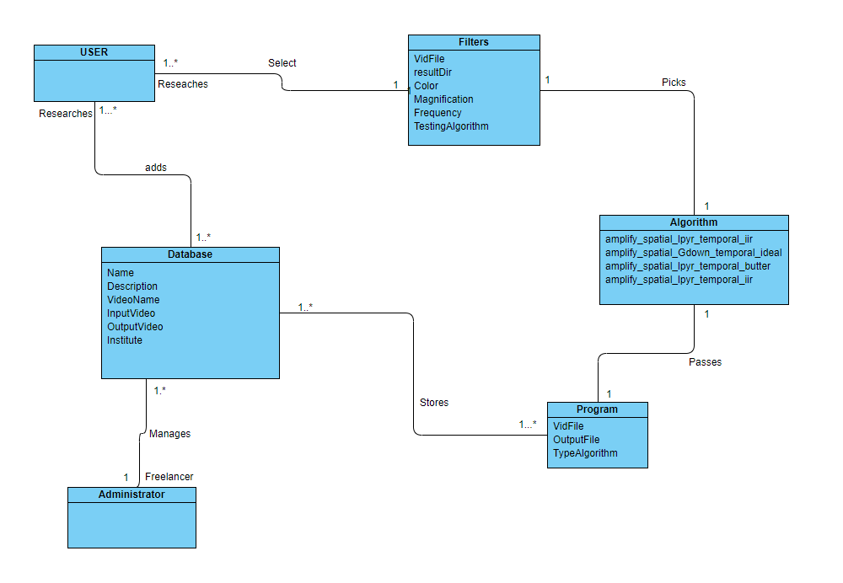

Figure 1

The figure 2 will cover the Program section. This will explain how the system calls the different functions and objects inherited from different classes. The OO MATLAB code will communicate with its classes and attributes to calling operations by the user.

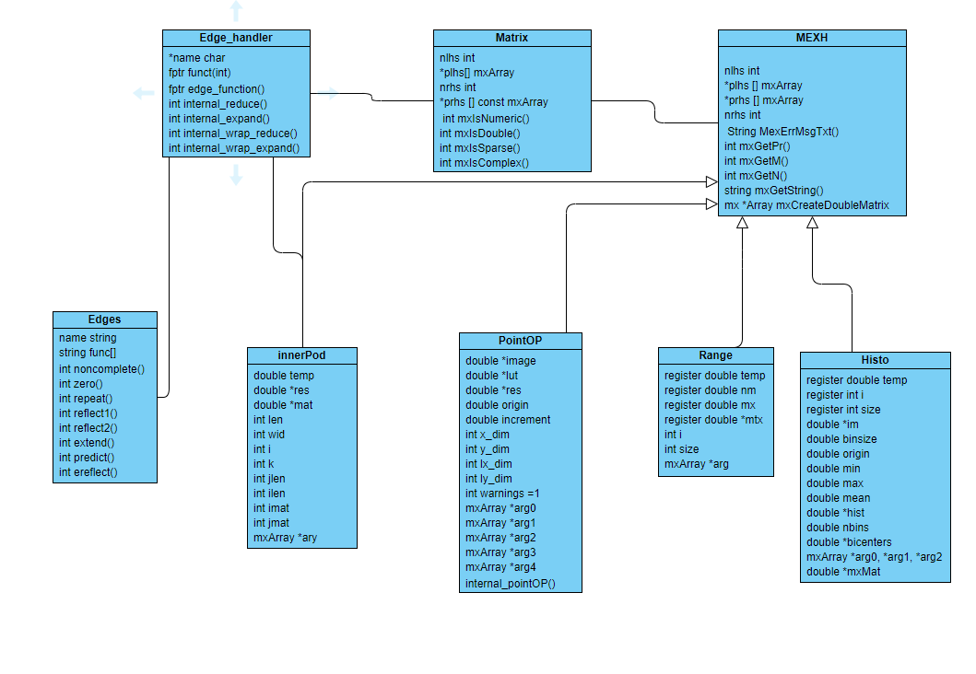

Figure 2

## 3.8 Architectural Model

The figure 1 of the Architectural Model will give a brief description about how the system structure is designed. We will be using N-Tier architecture because it is easy to solve when there is an issue even though it changes the structure.

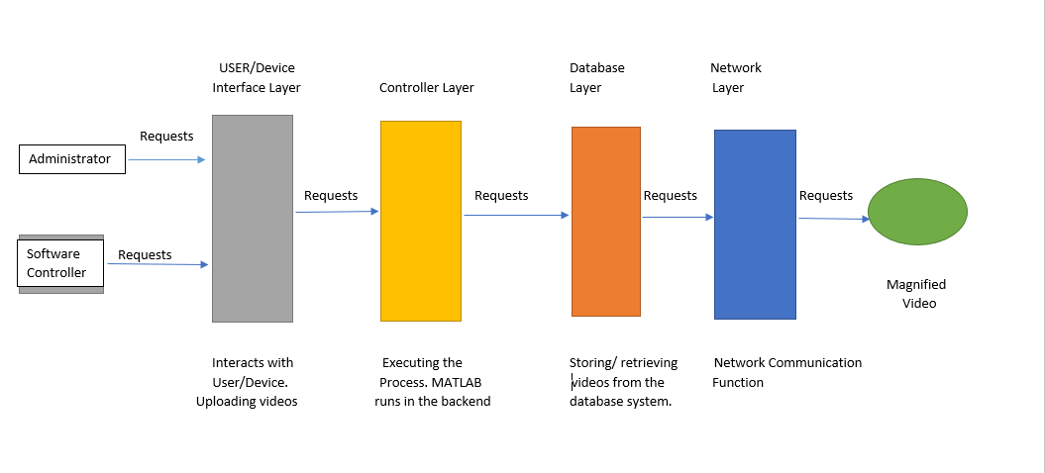

Figure 1

## 3.9 Additional Comments

The SRS document is included all the requirements necessary for the EMFV system. It also specifies the use functional and non-functional requirements, case diagrams, domain model diagrams, and architectural diagram for the system which helps to get the idea of the flow of the system.   
The system is designed for the public use in the first phase and it will be developed for more research-oriented activities in near future.